Supplementary Tutorial 2: Rodinia Australia
EarthByte Research Group, School of Geosciences, University of Sydney, Australia

Aim
This tutorial is designed to teach the user how to:
- Load vector data
- Experiment with colours
- 'Cookie-cut' data
- Save data
- Load raster data
- Reconstruct data (without agegrid)
- Reconstruct data (with agegrid)
- Export reconstructions (shapefiles and jpegs)
- Create an animation (using Quicktime or sequimago)
Screen shots have been included to illustrate how to complete new steps within each exercise.

Included files
The data bundle for this tutorial, ‘Supp2_Workflow', includes the following GPlates compatible feature files:
- Australia VGPs
- Australian Rodinian Provinces
- Coastline
- Rodinian cratonic blocks
- Australian magnetic anomaly raster
- Magmatic events polygon outlines
- 4 alternative Rodinia rotation files
See www.earthbyte.org/Resources/earthbyte_gplates.html for more EarthByte data sets.

Background
More detailed instructions on the use of Gplates are included in the Supp1_Workflow.
A movie of the following workflow is included in the 'Supp2_Workflow' folder

Exercise
1. Open GPlates
2. Load the files
File -> Open Feature Collection…
Locate the Supp2_Workflow folder and select all the compatible files by holding the Shift key
Open
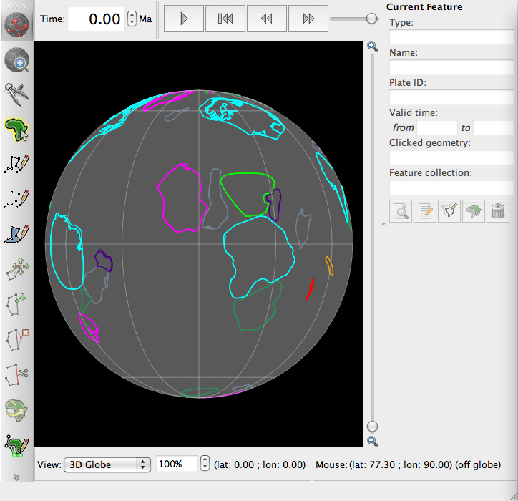
3. Using the Drag Globe Tool click (and hold) anywhere on the globe and drag it (move the mouse around) so you can see Australia. Now zoom into Australia using the wheel on your mouse or the vertical slider on the right of the Gplates window.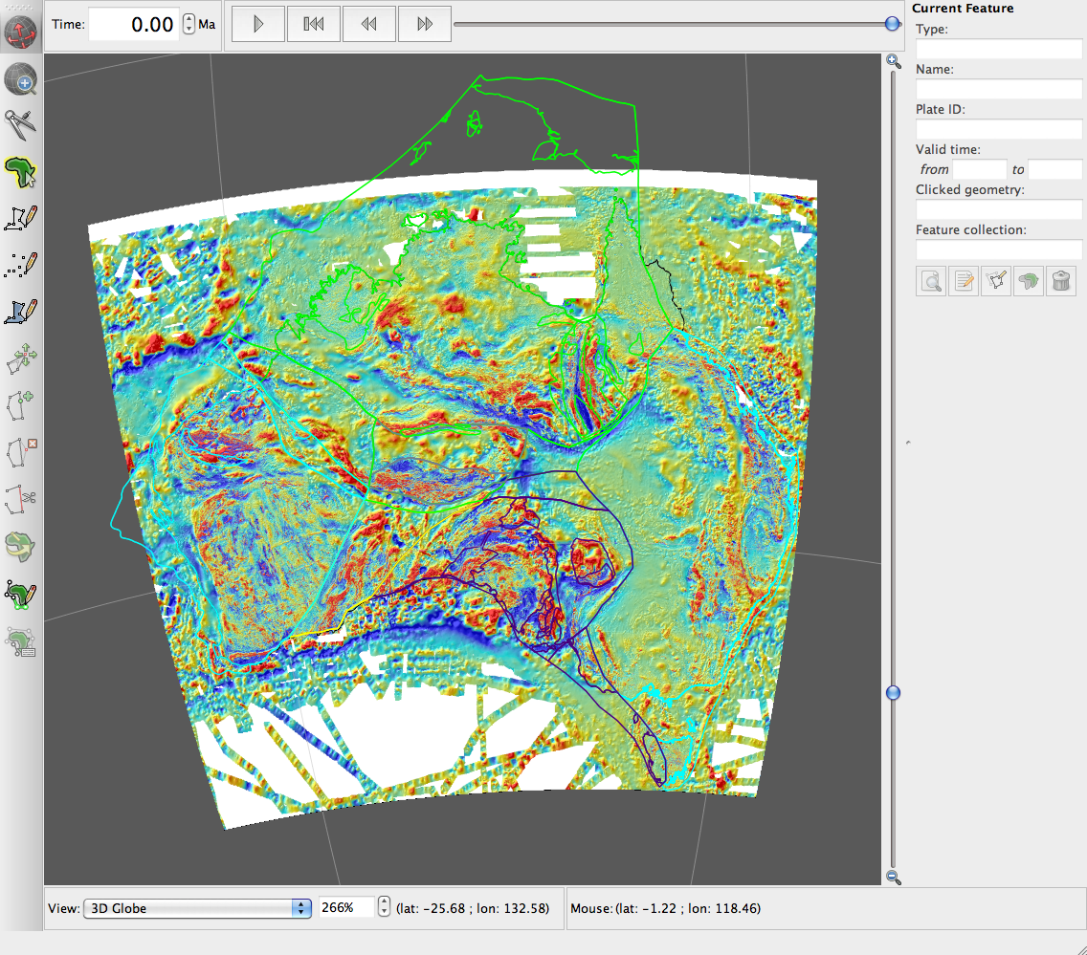
4. In the Layers Window link the Magnetic Anomaly raster to the Rodinian cratonic block polygons (CratonicBlocks_RodinianModels_16012012).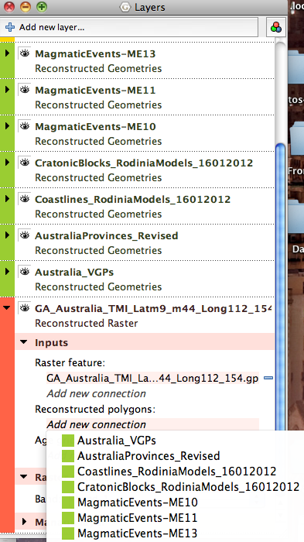
5. Make plate ID 8801 (Western Australia) the fixed plate
Reconstruction -> Specify Anchored Plate ID -> Type '8801' -> Ok
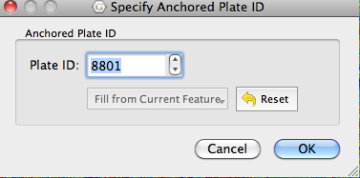
6. Reconstruct to 1300 Ma by typing in the time window and pressing enter.
7. Compare the different rotation files by selecting each option in turn using the tick box in the Layers Window.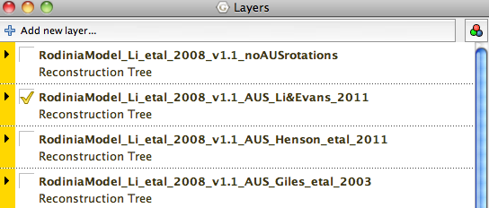
8. Make an animation running from 1700 Ma to 530 Ma using the Animation Configuration Window.
Reconstruction -> Configure Animation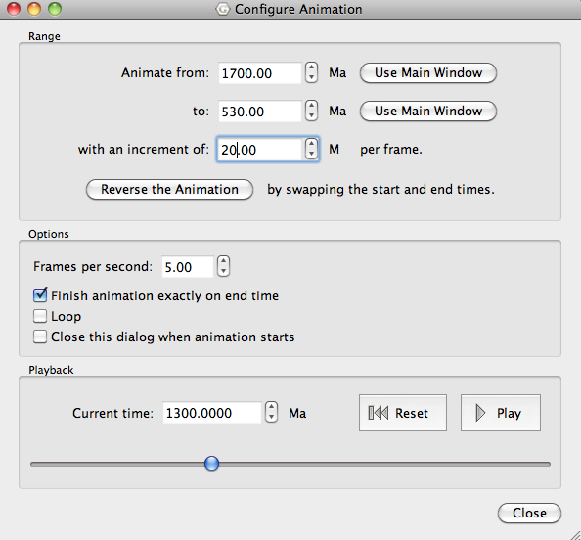
9. Reconstruct to 1070 Ma.
10. Rotate the globe so you can see the Virtual Geomagnetic Pole locations.
11. Use the Choose Feature tool to interrogate different points. 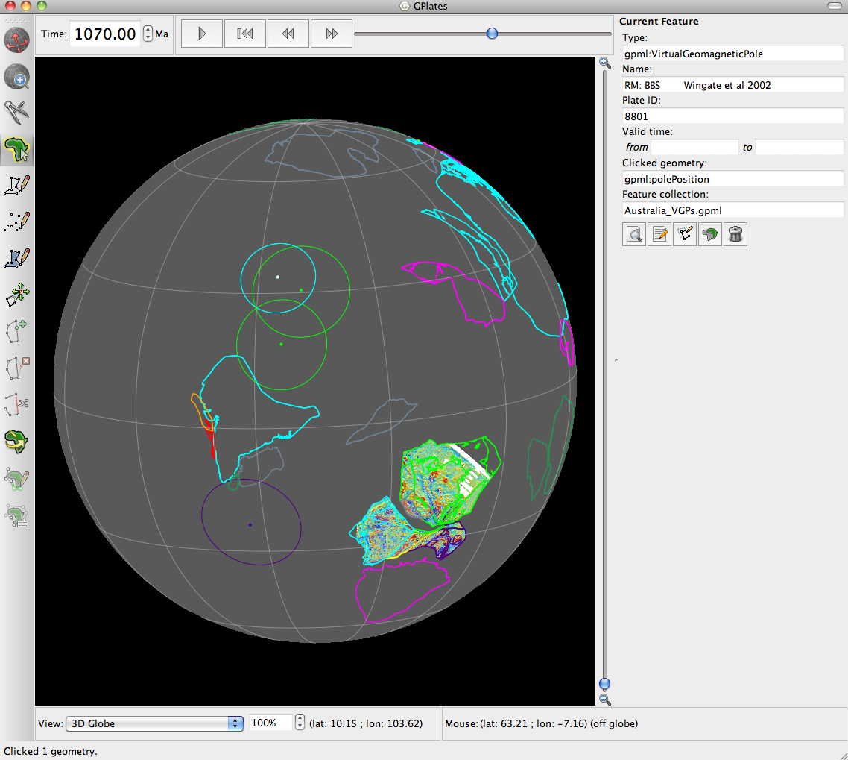

Notes on Data Sources
The primary source of information for the set of rotation files is the model for all of Rodinia described by Li et al (2008). The rotation file uses poles of rotation given in the appendix of this source. These rotations define the motions of each block from 530 Ma to 1100 Ma. No attempt has been made here to extend this global model either to earlier or later times.

The model of Li et al (2008) has been modified for Australia specifically. Three of the rotation files describe alternative scenarios for the relative motions between Australian cratonic blocks at various stages during the Proterozoic. These are "_AUS_Giles_etal_2003.rot", "_AUS_Henson_etal_2011.rot" and "_Li&Evans_2011.rot".
For the purposes of comparison, a fourth rotation file ("_noAUSrotations.rot") has been provided which contains no rotations within Australia. See text for further discussion and full citations to the source material.

CratonicBlocks_RodiniaModels_20092011.gpml
Polygons defining the outlines of the various cratonic blocks used in the Rodinia Model.
These polygons are based on those used by Li et al (2008) for the construction of the
IGCP Geodynamic map of Rodinia, available here:
http://www.tsrc.uwa.edu.au/440project/rodiniamaps
These polygons have been modified significantly for Australia, with other minor
modifications for other areas.

Coastlines_RodiniaModels_20092011.gpml
Polyline geometries defining present-day coastlines, with each segment attributed with the ID of the plate polygon in which it lies.

MagmaticEvents-ME**.gpml
Polygons defining magmatic events described by Claoué-Long and Hoatson (2008).
These polygons are a simplified version of the extents shown in the original source, and correspond to Magmatic Events ME10 to ME13. Our polygons are a simplification of the cited source material and don’t distinguish between the two subdivisions included in the GA report that distinguish between more definite and more interpretative zones.
The source material can be found here:
http://www.ga.gov.au/image_cache/GA17076.pdf
http://www.ga.gov.au/image_cache/GA11506.pdf

Australia_VGPs.gpml
Virtual Geomagnetic Poles for Australia. The data are mainly taken from the table provided in Li and Evans (2011), supplemented with additional data as described in Schmidt et al (2006). The original source for each VGP can be determined by clicking on this pole within GPlates.

GA_Australia_TMI_Latm45_m10_Long111_156[.jpg/.gpml]
Image showing Total Magnetic Intensity for Australia derived from the Geoscience Australia compilation available here:
https://www.ga.gov.au/products/servlet/controller?event=GEOCAT_DETAILS&catno=70282
Note that this image differs from that shown in the main text, where a Reduced to Pole magnetic anomaly map is used. This grid is not publicly available at time of writing.

References:

Claoué-Long, J.C., and Hoatson, D.M., 2009, Guide to using the Map of Australian Proterozoic Large Igneous Provinces, Geoscience Australia Record 2009/44, 37p.
Giles, D., Betts, P.G., and Lister, G.S., 2004, 1.8-1.5-Ga links between the North and South Australian cratons and the Early-Middle Proterozoic configuration of Australia: Tectonophysics, v. 380, p27-41.
Henson, P., Kositcin, N., and Huston, D., 2011, Broken Hill and Mount Isa: linked but not rotated, AUSGEO news, Geoscience Australia, 102, p13-17.
Li, Z., Bogdanova, S., Collins, A.S., Davidson, A., De Waele, B., Ernst, R., Fitzsimons, I., Fuck, R., Gladkochub, D., and Jacobs, J., 2008, Assembly, configuration, and break-up history of Rodinia: A synthesis: Precambrian Research, v. 160, p179-210.
Li, Z.X., and Evans, D.A.D., 2011, Late Neoproterozoic 40° intraplate rotation within Australia allows for a tighter-fitting and longer-lasting Rodinia: Geology, v. 39, p39.
Milligan, P.R., Franklin, R., Minty, B.R.S., Richardson, L.M. and Percival, P.J., 2010, Magnetic Anomaly Map of Australia (Fifth Edition), 1:15 000 000 scale, Geoscience Australia, Canberra.
Schmidt, P.W., Williams, G.E., Camacho, A., and Lee, J.K.W., 2006, Assembly of Proterozoic Australia: implications of a revised pole for the 1070 Ma Alcurra Dyke Swarm, central Australia: Geophysical Journal International, v. 167, p626-634.

